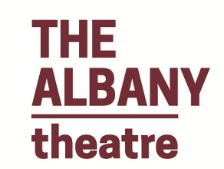
Dick Whittington Panto 2021/2022

REGISTRATION FORM (ADULT)

Applicant’s Details
Applicant’s Full Name:

Applicant’s Phone Number:

Applicant’s Email Address:

Previous Stage Experience (if any):

Application Details
Enter YES if you are interested in auditioning for any of the following parts:
Dick Whittington (female) |  | Alice
Alderman Fitzwarren |  | Fairy Bow Bells
King Rat |  | Sarah (Dame)
Idle Jack |  | Captain
1st Lieutenant |  | Sultan
Sultana |  | ENSEMBLE (Non-part)
For further information re times and venue and to obtain audition pieces, please complete this form to register your interest. Please complete by and Friday 27/08/21 and send to panto@albanytheatre.co.uk.

